**Unit 2: Process and Conceptual Modeling**

Conceptual models are abstract, psychological representations of how tasks should be carried out. People use conceptual models subconsciously and intuitively as a way of systematizing processes.

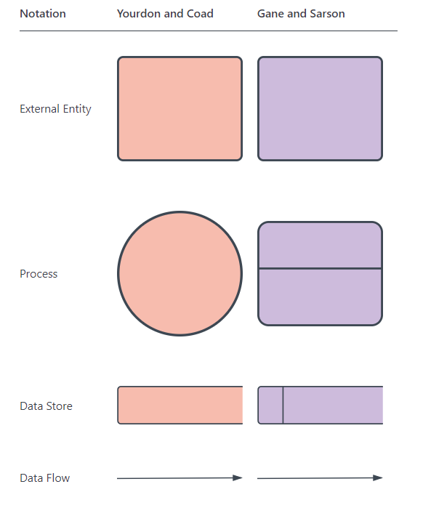2.1 Introduction to Data Flow Diagram (DFD)

A data flow diagram (DFD) maps out the flow of information for any process or system. It uses defined symbols like rectangles, circles and arrows, plus short text labels, to show data inputs, outputs, storage points and the routes between each destination. Data flowcharts can range from simple, even hand-drawn process overviews, to in-depth, multi-level DFDs that dig progressively deeper into how the data is handled. They can be used to analyze an existing system or model a new one. Like all the best diagrams and charts, a DFD can often visually “say” things that would be hard to explain in words, and they work for both technical and nontechnical audiences, from developer to CEO. That’s why DFDs remain so popular after all these years. While they work well for data flow software and systems, they are less applicable nowadays to visualizing interactive, real-time or database-oriented software or systems.

2.2 Concept used in drawings (DFD)

Using any convention’s DFD rules or guidelines, the symbols depict the four components of data flow diagrams.

1. **External entity:** An outside system that sends or receives data, communicating with the system being diagrammed. They are the sources and destinations of information entering or leaving the system. They might be an outside organization or person, a computer system or a business system. They are also known as terminators, sources and sinks or actors. They are typically drawn on the edges of the diagram.
2. **Process:** Any process that changes the data, producing an output. It might perform computations, or sort data based on logic, or direct the data flow based on business rules. A short label is used to describe the process, such as “Submit payment.”
3. **Data store:** Files or repositories that hold information for later use, such as a database table or a membership form. Each data store receives a simple label, such as “Orders.”
4. **Data flow:** The route that data takes between the external entities, processes and data stores. It portrays the interface between the other components and is shown with arrows, typically labeled with a short data name, like “Billing details.”

Rule of Data Flow

One of the rules for developing DFD is that all flow must begin with and end at a processing step. This is quite logical because data can’t transform on its own with being process. By using the thumb rule, it is quite easy to identify the illegal data flows and correct them in a DFD.

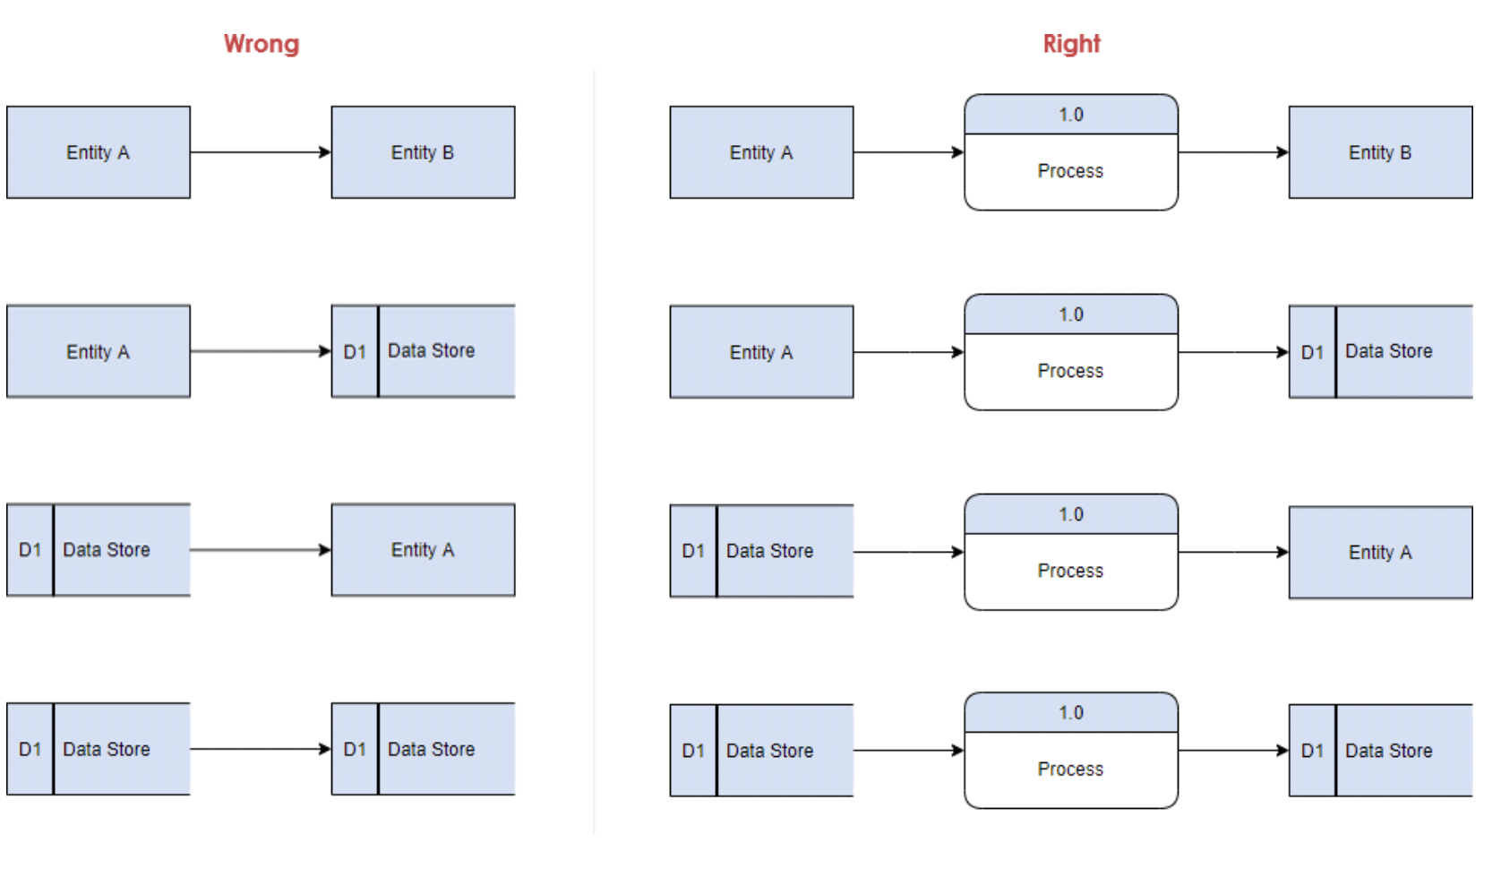

Fig. Rules of DFD

2.3 DFD design (up to level 2)

Levels or layers are used in DFDs to represent progressive degrees of detail about the system or process. These levels include:

* **Level 0:** Also known as a "context diagram," this is the highest level and represents a very simple, top-level view of the system being represented.
* **Level 1:** Still a relatively broad view of the system, but incorporates subprocesses and more detail.
* **Level 2:** Provides even more detail and continues to break down subprocesses as needed.

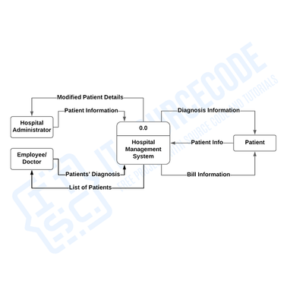

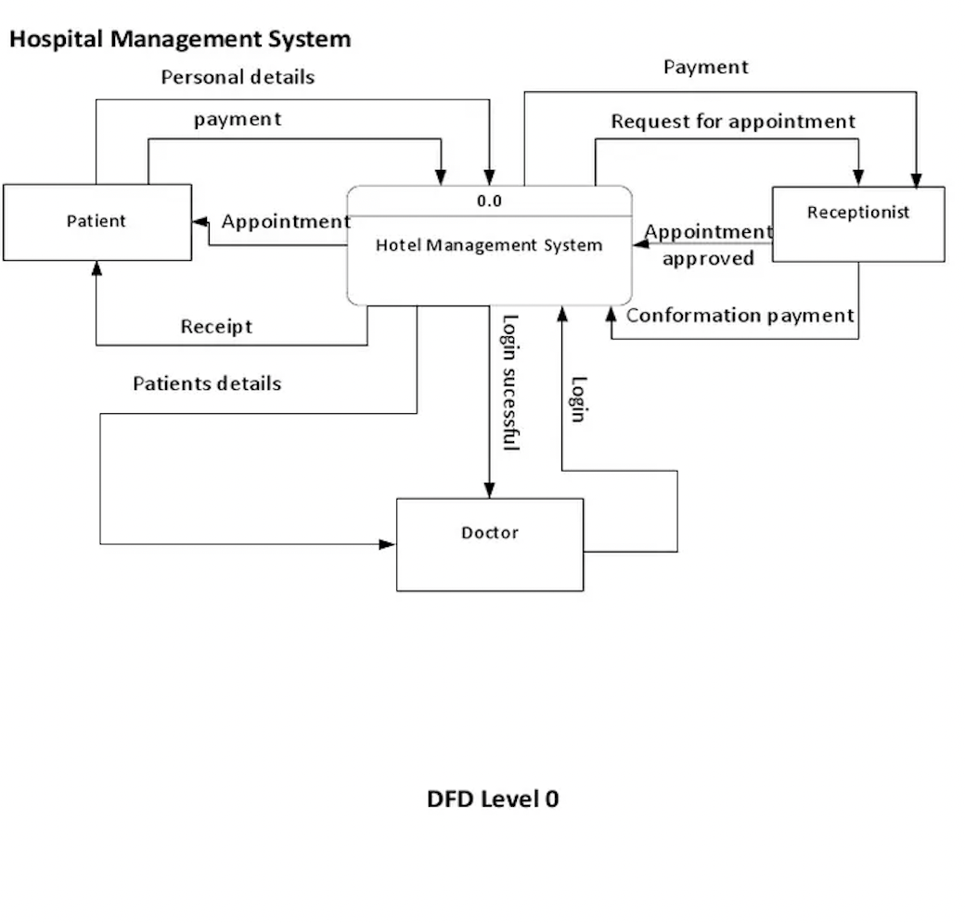

2.5 Entity Relationship Diagram

* ER model stands for an Entity-Relationship model. It is a high-level data model. This model is used to define the data elements and relationship for a specified system.
* It develops a conceptual design for the database. It also develops a very simple and easy to design view of data.
* In ER modeling, the database structure is portrayed as a diagram called an entity-relationship diagram.

**For example,** Suppose we design a school database. In this database, the student will be an entity with attributes like address, name, id, age, etc. The address can be another entity with attributes like city, street name, pin code, etc and there will be a relationship between them.

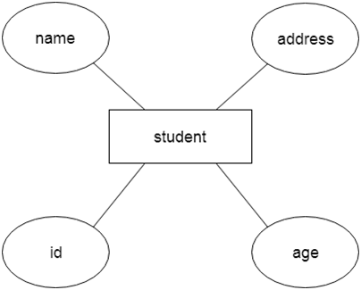

Component of ER Diagram

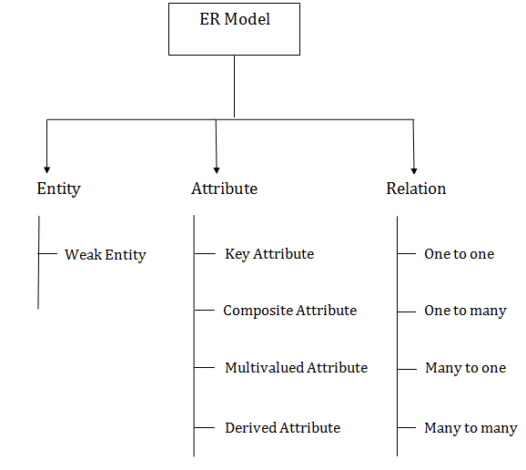

1. Entity:

An entity may be any object, class, person or place. In the ER diagram, an entity can be represented as rectangles.

Consider an organization as an example- manager, product, employee, department etc. can be taken as an entity.

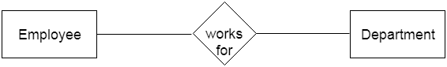 

**a. Weak Entity**

An entity that depends on another entity called a weak entity. The weak entity doesn't contain any key attribute of its own. The weak entity is represented by a double rectangle.

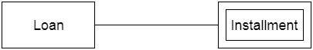 

2. Attribute

The attribute is used to describe the property of an entity. Eclipse is used to represent an attribute.

**For example,** id, age, contact number, name, etc. can be attributes of a student.

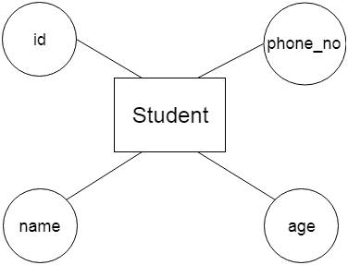  
 

**a. Key Attribute**

The key attribute is used to represent the main characteristics of an entity. It represents a primary key. The key attribute is represented by an ellipse with the text underlined.

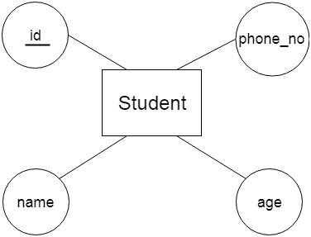  
 

**b. Composite Attribute**

An attribute that composed of many other attributes is known as a composite attribute. The composite attribute is represented by an ellipse, and those ellipses are connected with an ellipse.

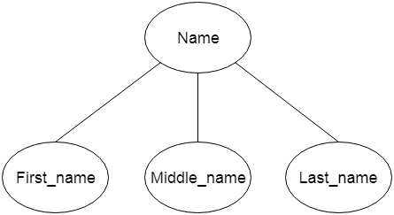  
 

**c. Multivalued Attribute**

An attribute can have more than one value. These attributes are known as a multivalued attribute. The double oval is used to represent multivalued attribute.

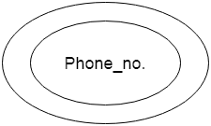**For example,** a student can have more than one phone number.

**d. Derived Attribute**

An attribute that can be derived from other attribute is known as a derived attribute. It can be represented by a dashed ellipse.

**For example,** A person's age changes over time and can be derived from another attribute like Date of birth.

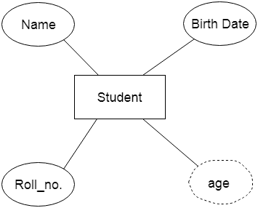  
 

3. Relationship

A relationship is used to describe the relation between entities. Diamond or rhombus is used to represent the relationship.

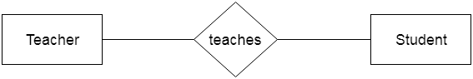 

Types of relationship are as follows:

**a. One-to-One Relationship**

When only one instance of an entity is associated with the relationship, then it is known as one to one relationship.

**For example,** A female can marry to one male, and a male can marry to one female.

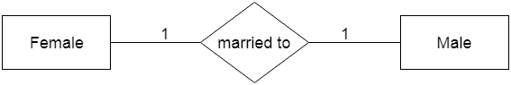 

**b. One-to-many relationship**

When only one instance of the entity on the left, and more than one instance of an entity on the right associates with the relationship then this is known as a one-to-many relationship.

**For example,** Scientist can invent many inventions, but the invention is done by the only specific scientist.

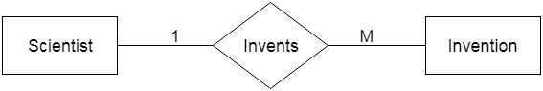 

**c. Many-to-one relationship**

When more than one instance of the entity on the left, and only one instance of an entity on the right associates with the relationship then it is known as a many-to-one relationship.

**For example,** Student enrolls for only one course, but a course can have many students. 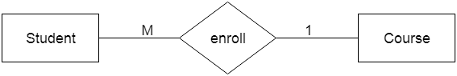

**d. Many-to-many relationship**

When more than one instance of the entity on the left, and more than one instance of an entity on the right associates with the relationship then it is known as a many-to-many relationship.

**For example,** Employee can assign by many projects and project can have many employees.

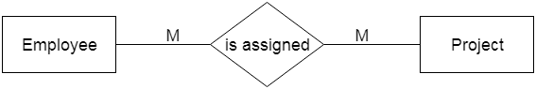

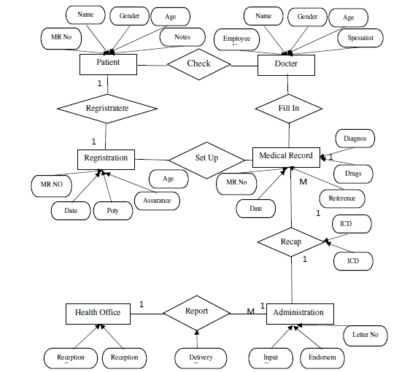E-R Diagram example

Fig. E-R Diagram